RK平台SD/SDIO/eMMC排查

一、硬件： 1
二、波形： 2
三、LOG分析： 3

（注意：一般情况下先确认硬件，90%的问题都是硬件问题引起，所以先确认硬件！还要注意低级的io复用错误）

一：硬件排查
（1）、SD卡
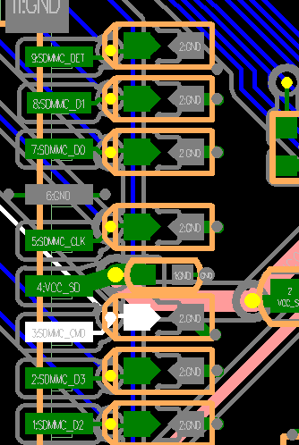
从左到右依次是：
DET ---- 检测脚
DATA1 ---- 数据线
DATA0
GND
CLK ---- 时钟
VCC_SD ---- SD卡供电电源
VCCIO_SD ---- 数据线的IO供电电源
CMD ---- 命令线
DATA3
DATA2
1、 除了DET/CLK/GND外，其它的DATA0-3/VCC_SD/VCCIO_SD/CMD必须都为3.3v左右，最小不能低于3v；DET脚插入为低，拔出为高； DATA0-3/CMD的电压都是VCCIO_SD供给的，所以DATA0-3/CMD必须跟VCCIO_SD保持一致，而VCC_SD和VCCIO_SD要保持一致（NOTE: SD 3.0，要求VCCIO_SD为1.8v）；
2、如果VCC_SD/VCCIO_SD的电源是长供电，那么请保证VCC_SD和VCCIO_SD在卡拔插时不会有塌陷；
3、对应VCCIO_SD：RK3188/RK312X/RK322X是没有这个，直接由VCC_IO供电；
（2）、SDIO：
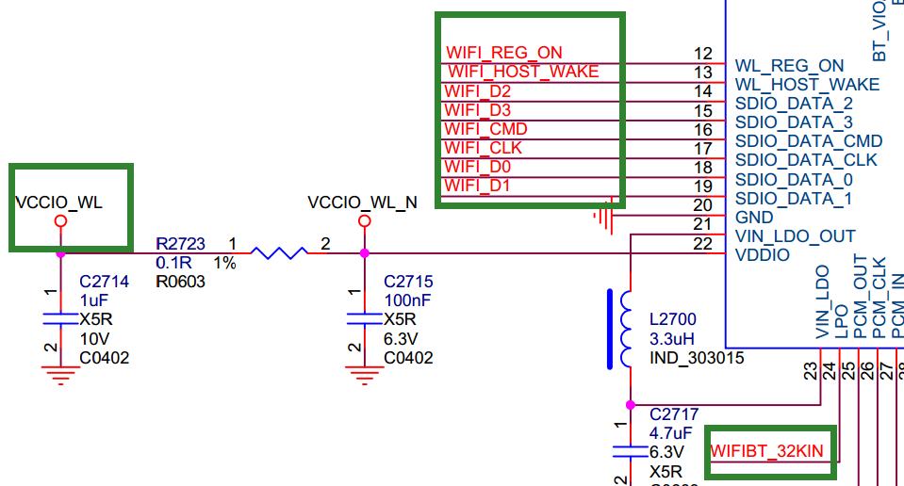

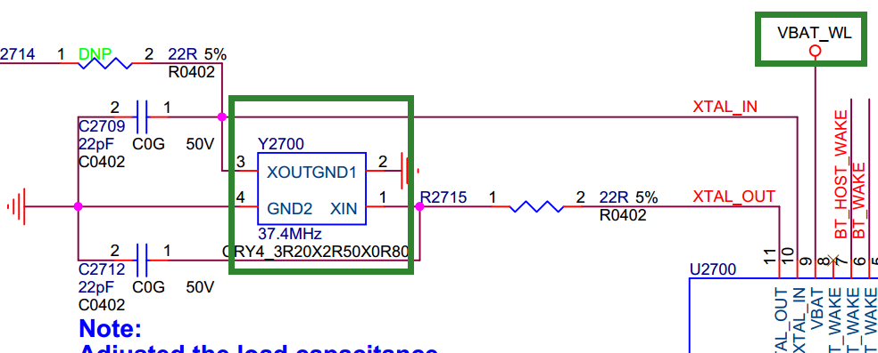

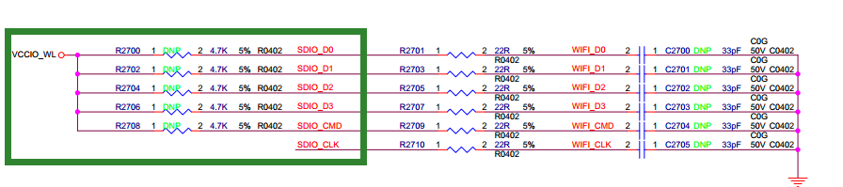

首先看下硬件：主要的部分都在绿色方框内
WIFI_D0~3：数据线，平时为高，电压取决于VCCIO_WL的电压；
WIFI_CMD：命令线，平时为高，电压取决于VCCIO_WL的电压；
WIFI_CLK：时钟，平时为低，电压取决于VCCIO_WL的电压；
VBAT_WL：WIFI模组供电电源，一直都为高，供电需打印3.3v；
VCCIO_WL：给DATA/CMD/CLK的IO供电电源，可以为3.3或者1.8v，但SDIO3.0
必须为1.8v；
WIFI_REG_ON: 正常工作时为3.3v，WiFi关闭时为0v；
两个晶振：32K和26M/37.4M,正常工作时都会有波形输出；
(3)、eMMC：
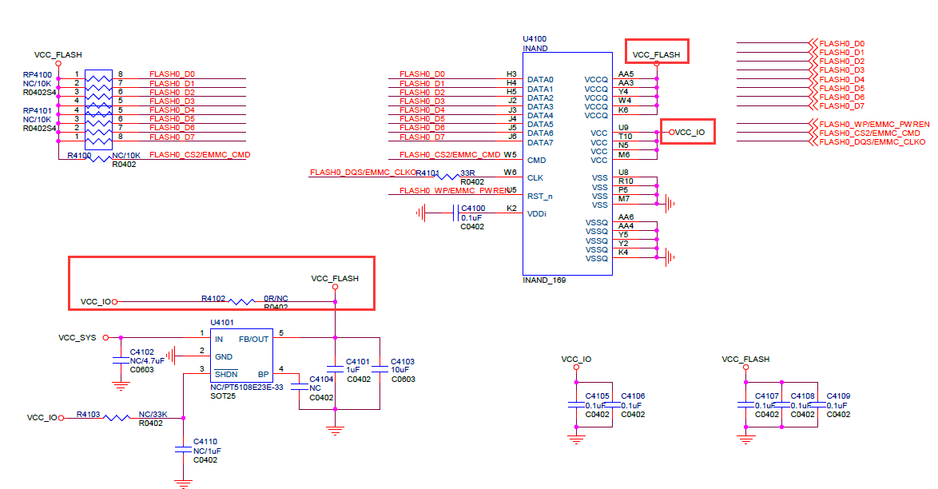

eMMC有效电压的组合：
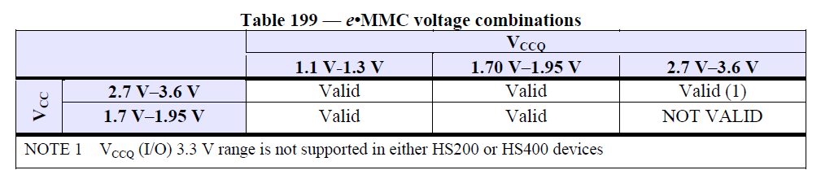
- VCC_FLASH 对应 VCC；
- VCC_IO 对应 VCCQ；
- 确保eMMC_CMD/DATA0~7/VCC_IO电压都一致（1.8或3.3v）；
- 确保 VCC_FLAHS/VCC_IO的电压在开机和运行时或者休眠唤醒时必须保持稳定、不能有塌陷或者纹波过大的情况；
- 有条件的话，测下clk和cmd以及data的波形质量，确保波形正常；

二：波形分析

下图是SD卡识别模式时的波形时序图（sdio、emmc都一样）：
简单说一下识别SD卡的方式：主控发出48clk并携带48bit的数据发给SD卡，而SD卡要回应给主控48clk加48bit的数据；如下图：
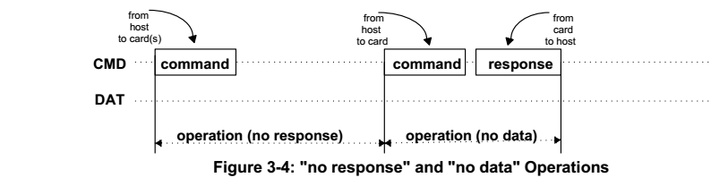

绿色：SDMMC_CLK
黄色：SDMMC_CMD SDMMC_CMD空闲时一直处于高电平；
主控发出的波形： 当最开始的两个电平有一高一低时，是主控发出去的命令；
SD卡响应的波形： 当最开始的两个电平有连续的两个低电平是表示卡端有响应；
其次主控和响应一般包含48个bit的数据，所以48个clk为一个完整的包。要确认的就是：主控发出去命令包后,SD卡端是否有响应。

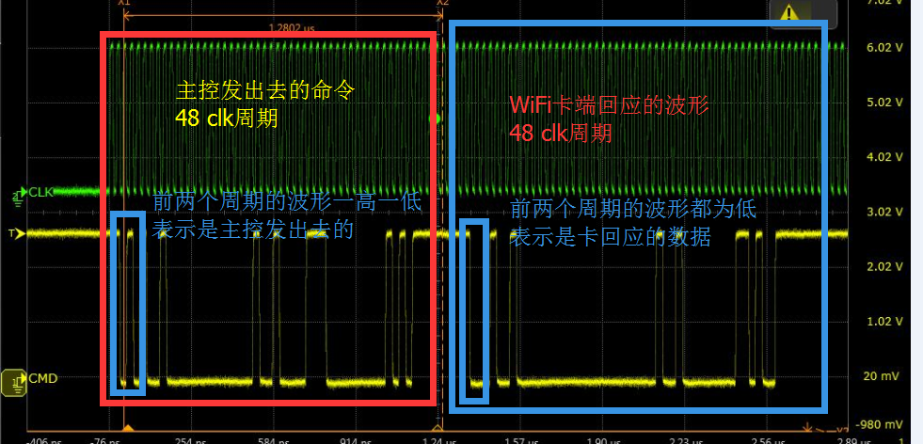

三：LOG分析：
SD卡：
一、VOLD上层未执行挂载动作：
[ 292.867492] mmc_host mmc1: Bus speed (slot 0) = 23000000Hz (slot req 400000Hz, actual 396551HZ div = 29)
[ 292.867621] rk_sdmmc: BOOT dw_mci_setup_bus: argue clk_mmc workaround out 800000Hz for init[mmc1]
[ 293.163454] mmc1: Skipping voltage switch
[ 293.193415] mmc_host mmc1: Bus speed (slot 0) = 23000000Hz (slot req 23000000Hz, actual 23000000HZ div = 0)
[ 293.193544] rk_sdmmc: BOOT dw_mci_setup_bus: argue clk_mmc workaround out normal clock [mmc1]
[ 293.193917] rk_sdmmc: BOOT Bus speed=23000000Hz,Bus width=4bits.[mmc1]
[ 293.194013] mmc1: new high speed SDXC card at address 59b4
[ 293.198185] mmcblk1: mmc1:59b4 00000 59.6 GiB
[ 293.204351] mmcblk1: p1

手动mount下：
mount -t vfat /dev/block/mmcblk1p1 /mnt
或者
mount -t vfat /dev/block/mmcblk1 /mnt
然后到mnt目录下看下是否有SD卡里面的文件
如果可以，请重新提一个问题：android vold未去执行挂载动作；
- 开机不读卡,运行时拔插OK：大概率时电源问题
例如：拔掉所有电源，发现查着HDMI发现有漏电到VCC_SD卡里面；
三、挂载失败：
<3>[ 2229.405694] FAT-fs (mmcblk1p1): bogus number of reserved sectors
<6>[ 2229.405751] FAT-fs (mmcblk1p1): Can't find a valid FAT filesystem
请格式化SD卡为FAT32文件系统；
或者NTFS: make menuconfig 选择NTFS文件系统的支持即可；
四、IOMUX被复用：
dwmmc_rockchip 10214000.rksdmmc: req failed (CMD51): error = -110, timeout = 4000ms
dwmmc_rockchip 10214000.rksdmmc: [mmc1] -- Timeout recovery procedure start --
mmc_host mmc1: Bus speed (slot 0) = 37500000Hz (slot req 400000Hz, actual 398936HZ div = 47)
dwmmc_rockchip 10214000.rksdmmc: [mmc1] -- Timeout recovery procedure finished --
mmc1: error -110 whilst initialising SD card

五、概率性不识别：
rk_sdmmc: BOOT dw_mci_setup_bus: argue clk_mmc workaround out normal clock [mmc1]
rk_sdmmc: BOOT Bus speed=50000000Hz,Bus width=4bits.[mmc1]
mmc1: new high speed SD card at address b368
mmcblk1: mmc1:b368 SMI 486 MiB
[mmc1] Data transmission error !!!! MINTSTS: [0x00002000]
[mmc1] host was already tuning, Don't need to retry tune again ignore
[mmc1] host was already tuning, Don't need to retry tune again ignore 0.
dwmmc_rockchip ff0c0000.rksdmmc: data FIFO error (status=00002000)
mmcblk1: error -110 sending status command, retrying
need_retune:0,brq->retune_retry_done:0.

降频和增加延时增强稳定性，如果降低37.5M不行，继续降低20M确认问题，如果降频OK的话，请检查硬件layout；
&sdmmc {
- clock-frequency = <50000000>;
- clock-freq-min-max = <400000 50000000>;
- card-detect-delay = <200>;
+ clock-frequency = <37500000>;
+ clock-freq-min-max = <400000 37500000>;
+ card-detect-delay = <1200>;

&sdmmc {
- clock-frequency = <37500000>;
- clock-freq-min-max = <400000 37500000>;
- card-detect-delay = <200>;
+ clock-frequency = <20000000>;
+ clock-freq-min-max = <400000 20000000>;
+ card-detect-delay = <1200>;

- 其他情况：
（1）、TF卡已经mount，但不能访问TF卡目录，看起来是卡文件系统问题，但卡在Windows下可以访问。
kmsg：
mmc_host mmc1: Bus speed (slot 0) = 50000000Hz (slot req 400000Hz, actual 396825HZ div = 63)
rk_sdmmc: BOOT dw_mci_setup_bus: argue clk_mmc workaround out 800000Hz for init[mmc1]
mmc_host mmc1: Bus speed (slot 0) = 50000000Hz (slot req 50000000Hz, actual 50000000HZ div = 0)
rk_sdmmc: BOOT dw_mci_setup_bus: argue clk_mmc workaround out normal clock [mmc1]
rk_sdmmc: BOOT Bus speed=50000000Hz,Bus width=4bits.[mmc1]
mmc1: new high speed SD card at address 1234
mmcblk1: mmc1:1234 SA02G 1.85 GiB
mmcblk1: p1
[67066.129119] fat__get_entry: 118 callbacks suppressed
[67066.129148] FAT-fs (mmcblk1p1): Directory bread(block 480) failed
[67066.129370] FAT-fs (mmcblk1p1): Directory bread(block 489) failed
[67078.513207] fat__get_entry: 22 callbacks suppressed
[67078.513277] FAT-fs (mmcblk1p1): Directory bread(block 480) failed
[67078.514063] FAT-fs (mmcblk1p1): Directory bread(block 489) failed
尝试使用fsck对TF卡做修复

(2)、硬件问题，io电压异常
slot->flags = 1
CPU: 3 PID: 6 Comm: kworker/u8:0 Not tainted 3.10.0 #278
Workqueue: kmmcd mmc_rescan
[<c0013e24>] (unwind_backtrace+0x0/0xe0) from [<c001172c>] (show_stack+0x10/0x14)
[<c001172c>] (show_stack+0x10/0x14) from [<c04fa444>] (dw_mci_set_ios+0x9c/0x21c)
[<c04fa444>] (dw_mci_set_ios+0x9c/0x21c) from [<c04e7748>] (mmc_set_chip_select+0x18/0x1c)
[<c04e7748>] (mmc_set_chip_select+0x18/0x1c) from [<c04ebd5c>] (mmc_go_idle+0x94/0xc4)
[<c04ebd5c>] (mmc_go_idle+0x94/0xc4) from [<c0748d80>] (mmc_rescan_try_freq+0x54/0xd0)
[<c0748d80>] (mmc_rescan_try_freq+0x54/0xd0) from [<c04e85d0>] (mmc_rescan+0x2c4/0x390)
[<c04e85d0>] (mmc_rescan+0x2c4/0x390) from [<c004d738>] (process_one_work+0x29c/0x458)
[<c004d738>] (process_one_work+0x29c/0x458) from [<c004da88>] (worker_thread+0x194/0x2d4)
[<c004da88>] (worker_thread+0x194/0x2d4) from [<c0052fb4>] (kthread+0xa0/0xac)
[<c0052fb4>] (kthread+0xa0/0xac) from [<c000da98>] (ret_from_fork+0x14/0x3c)
1409..dw_mci_set_ios: wait for unbusy timeout....... STATUS = 0x306 [mmc1]

WiFi：
（1）、电压问题，排查WIFI_DATA线的电压以及VCCIO_WL电压
[ 100.086615] slot->flags = 3
[ 100.086628] CPU: 0 PID: 113 Comm: kworker/u8:3 Tainted: P W O 3.10.0 #250
[ 100.086644] Workqueue: kmmcd mmc_rescan
[ 100.086663] [<c0013e04>] (unwind_backtrace+0x0/0xe0) from [<c0011720>] (show_stack+0x10/0x14)
[ 100.086677] [<c0011720>] (show_stack+0x10/0x14) from [<c050d3b4>] (dw_mci_set_ios+0x9c/0x21c)
[ 100.086689] [<c050d3b4>] (dw_mci_set_ios+0x9c/0x21c) from [<c04fabd4>] (mmc_power_up+0x60/0xa0)
[ 100.086700] [<c04fabd4>] (mmc_power_up+0x60/0xa0) from [<c04faeac>] (mmc_rescan_try_freq+0x14/0xd0)
[ 100.086710] [<c04faeac>] (mmc_rescan_try_freq+0x14/0xd0) from [<c04fb7b4>] (mmc_rescan+0x204/0x298)
[ 100.086722] [<c04fb7b4>] (mmc_rescan+0x204/0x298) from [<c00471f0>] (process_one_work+0x29c/0x458)
[ 100.086734] [<c00471f0>] (process_one_work+0x29c/0x458) from [<c0047540>] (worker_thread+0x194/0x2d4)
[ 100.086745] [<c0047540>] (worker_thread+0x194/0x2d4) from [<c004ca28>] (kthread+0xa0/0xac)
[ 100.086759] [<c004ca28>] (kthread+0xa0/0xac) from [<c000da98>] (ret_from_fork+0x14/0x3c)
[ 100.086767] 1400..dw_mci_set_ios: wait for unbusy timeout....... STATUS = 0x206 [mmc2]
[ 102.546615] 1009..mci_send_cmd: wait for unbusy timeout.......[mmc2]
[ 102.595819] mmc_host mmc1: Timeout sending command (cmd 0x202000 arg 0x0 status 0x80202000)
有两种可能：
WiFi异常，排查VBAT_WL和WIFI_REG_ON以及晶振是否正常
走线太长导致波形质量很差，降频或者修改硬件
dwmmc_rockchip 10218000.rksdmmc: req failed (CMD52): error = 110, timeout = 8000ms
[mmc2] - Timeout recovery procedure start --
rk_sdmmc: BOOT dw_mci_setup_bus: argue clk_mmc workaround out 800000Hz for init[mmc2]
mmc_host mmc2: Bus speed (slot 0) = 37500000Hz (slot req 400000Hz, actual 398936HZ div = 47)
rk_sdmmc: BOOT dw_mci_setup_bus: argue clk_mmc workaround out 800000Hz for init[mmc2]
[mmc2] -- Timeout recovery procedure finished --

（3）、走线太长导致波形质量很差，降频或者修改硬件
[ 200.731403] [mmc2] Data transmission error !!!! MINTSTS: [0x00000080]
[ 200.731426] [mmc2] host was already tuning, Don't need to retry tune again ignore 0.
（4）、WIFI_REG_ON或者WiFi硬件异常
rk_sdmmc: BOOT dw_mci_setup_bus: argue clk_mmc workaround out 800000Hz for init[mmc2]
rk_sdmmc: BOOT dw_mci_setup_bus: argue clk_mmc workaround out 400000Hz for init[mmc2]
rk_sdmmc: BOOT dw_mci_setup_bus: argue clk_mmc workaround out 600000Hz for init[mmc2]

